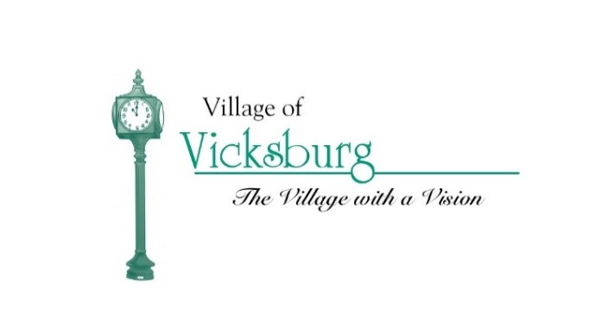
Vicksburg Parks & Recreation Committee
126 North Kalamazoo Ave.
Vicksburg, MI 49097
REGULAR MEETING DATES
The Vicksburg Parks and Recreation Committee has established the following regular meeting schedule for calendar years July 2017 thru June 2018. The committee will meet on the second Thursday of each month at 6:30 PM at the Vicksburg Community Building in the Merritt Harper Room – First Floor.
Thursday, May 11, 2017
Thursday, June 8, 2017
Thursday, July 13, 2017
Thursday, August 10, 2017
Thursday, September 14, 2017
Thursday, October 12, 2017
Thursday, November 9, 2017
Thursday, December 14, 2017
Thursday, November10, 2017
Thursday, December 14, 2017
Thursday, January 11, 2018
Thursday, February 8, 2018
Thursday, March 8, 2018
Thursday, April 12, 2018
Thursday, May 10, 2018
Thursday, June 14, 2018

This meeting notice is to be posted in the Village Office and on the Village Website.

