**VILLAGE OF VICKSBURG**

**CHRISTMAS IN THE VILLAGE FLOAT AND VEHICLE PARADE REGISTRATION**

**6:00 PM SATURDAY,**

**DECEMBER 10, 2022.**

**LINE-UP AT 5:00 PM AT THE**

**SCHOOL ADMINISTRATION BUILDING**

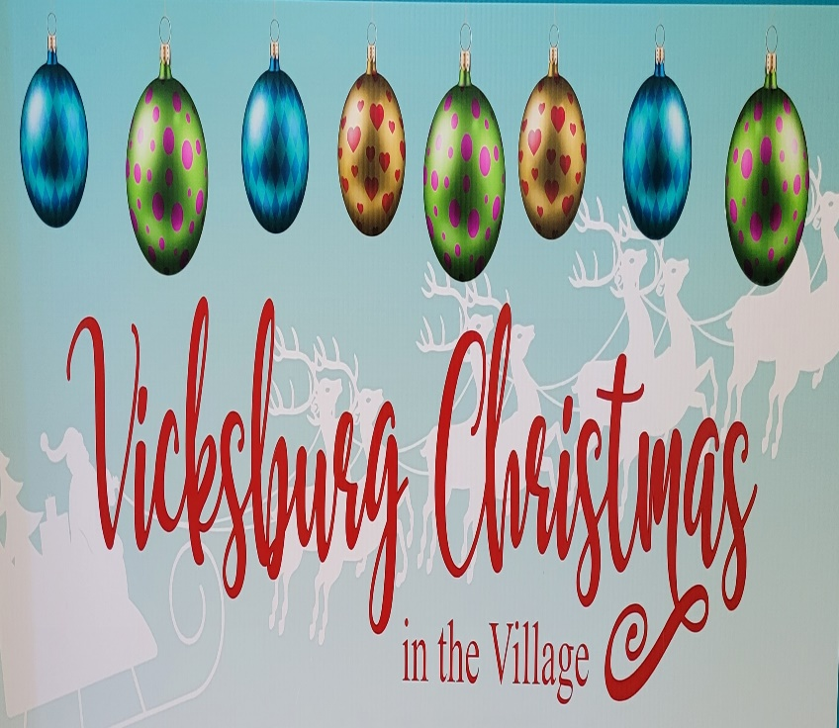

**CASH PRIZES**

**Best Float**: 1st place $300; 2nd place $200; 3rd Place $100

**Best Fire Truck**: $200; **Best Other (bikes, boats, planes, trains?) Vehicle** $200

Judging will be by a panel of celebrities

**Rules**

Floats should be a minimum of 8 feet in length not including the tow vehicle.

Tow vehicles must be decorated.

Floats should include skirt to cover wheels.

Floats must incorporate lights in the design. ***No candy thrown from floats or vehicles***

Name of Float/Truck/Vehicle/Other____________________________________________

Sponsored By_____________________________________________________________

Contact_____________________________ Phone_______________________________

Email____________________________________________________________________

Float Description___________________________________________________________

Send the above information by Friday, November 25 to: Village of Vicksburg, 126 N. Kalamazoo Ave., Vicksburg, MI 49097

Questions to: [info@vicksburgmi.org](mailto:info@vicksburgmi.org)