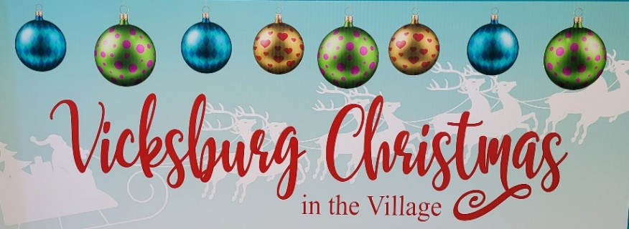
2022 Christmas in the Village Sponsorships
Saturday, December 10th, 2022

Support your downtown this holiday season by sponsoring some of the activities designed to create a festive destination for the whole family. Christmas in the Village is hosted by the Village of Vicksburg. Some of the entertainment planned for this year includes horse wagon and tractor rides, Christmas Card Lane, carolers, a magic show, local performers, and more. The goal of the event is to increase awareness of Vicksburg as a great place to work, live and play. We need your community support to continue making Vicksburg a great destination to visit in Southwest Michigan!
Contact info@vicksburgmi.org for more information.
Event Schedule
12:00 pm--5:00 pm Craft Shows (Vicksburg United Methodist Church, The Wooden Stitch)
3:00 pm--5:00 pm Shopping, Carolers, Horse Wagon Rides, Winter Farmers’ Market, Santa’s Tent, and much more!
4:30 pm--6:00 pm Restaurant & Santa Feast Specials
6:00 pm--7:00 pm Christmas Parade/Float Contest
7:00 pm--7:15 pm Tree Lighting Ceremony
7:15 pm--7:45 pm Magic Show

North Pole Sponsorship $1,500 (One Maximum) Sold Pending Approval
- Company logo in the South County Newspaper as a title sponsor
- Company name listed on event schedule available at businesses and handed out the day of the event
- Color logo on event signage, promotional material, Facebook and vicksburgmi.org
- Company logo on fliers businesses will hand out to their customers as the presenting sponsor
- Organization name highlighted as presenting sponsor in event news releases
- Contribution to enhance the image of Vicksburg in Southwest Michigan
Transportation Sponsorship $1,200 (One Maximum) Sold Pending Approval
- Company logo placed on all transportation vehicles and on the wagon tours during the day
- Company name listed on event schedule available at businesses and handed out the day of the event
- Company name on promotional materials, Facebook and vicksburgmi.org
- Company logo in the South County Newspaper as a title sponsor
- Organization name highlighted in event news releases
- Contribution to enhance the image of Vicksburg in Southwest Michigan
Children’s Elf Workshop $1,000 (One Maximum) Sold Pending Approval
- Company named listed on event schedule handed out during event
- Company name on Facebook and vicksburgmi.org
- Company logo in the South County Newspaper as a title sponsor
- Organization name highlighted in event news releases
- Contribution to enhance the image of Vicksburg in Southwest Michigan
- Company logo placed on signage at the Tree Lighting Ceremony site in Oswalt Park
Christmas Tree Sponsorship $850 (One Maximum)

- Company name listed on the event schedule available at businesses and handed out the day of the event
- Company name on Facebook and vicksburgmi.org
- Company logo in the South County Newspaper as a title sponsor
- Organization name highlighted in event news releases
- Contribution to enhance the image of Vicksburg in Southwest Michigan
Christmas Card Lane Tractor Sponsorship $400
- Company logo placed on signage at the pickup and drop off location in Christmas Card Lane
- Company name listed on the event schedule available at businesses and handed out the day of the event
- Company name on Facebook and vicksburgmi.org
- Company logo in the South County Newspaper as an event sponsor
- Organization name highlighted in event news releases
- Contribution to enhance the image Vicksburg in Southwest Michigan
Santa’s Tent Sponsorship $400 (One Maximum)
- Company logo placed inside the tent throughout the event
- Company name listed on event schedule available at businesses and handed out the day of the event
- Company name on Facebook and vicksburgmi.org
- Company logo in the South County Newspaper as an event sponsor
- Organization name highlighted in event news releases
- Contribution to enhance the image of Vicksburg in Southwest Michigan
Children’s Activities Tent Sponsorship $400 (One Maximum)
- Company logo placed inside the tent throughout the event
- Company name listed on event schedule available at businesses and handed out the day of the event
- Company name on Facebook and vicksburgmi.org
- Company logo in the South County Newspaper as an event sponsor
- Organization name highlighted in event news releases
- Contribution to enhance the image of Vicksburg in Southwest Michigan
Ice-Burg Sponsorship $250 (No Maximum)
- Company logo placed as a sponsor on all posters, flyers and registration documents
- Company logo in the South County Newspaper as an event sponsor
- Company name on Facebook and vicksburgmi.org
- Contribution to enhance the image of Vicksburg in Southwest Michigan
Event Schedule Sponsorship $50 (No Maximum)
- Company logo in the South County Newspaper as a sponsor
- Company name on Facebook and vicksburgmi.org
- Contribution to enhance the image of Vicksburg in Southwest Michigan

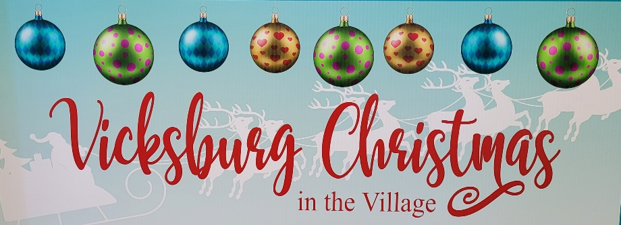

- My organization wishes to become a sponsor:

Organization/Name:___________________________________________________________________________

Address (City, State Zip):________________________________________________________________________

Phone number:______________________________________________________________________________

Email:______________________________________________________________________________________

Contact Name____________________________________________ Title:_______________________________

- We plan on participating at the sponsor level checked off below:

- $1,500 North Pole Sponsorship SOLD

- $1,200 Transportation Sponsorship SOLD

- $1,000 Children’s Elf Workshop Sponsorship SOLD

- $850 Christmas Tree Sponsorship SOLD

- $400 Christmas Card Lane Tractor Sponsor

- $400 Santa’s Tent Sponsorship SOLD

- $400 Children’s Activity Tent Sponsorship

- $250 Ice-burg Sponsorship

- $50 Event Schedule Sponsorship

- List how your organization/name should be listed on the marketing materials/signage:

For more information contact the Village of Vicksburg at info@vicksburgmi.org.
Return this form with check payable to the Village of Vicksburg
Village of Vicksburg, 126. N Kalamazoo Ave, Vicksburg, MI 49097, (269) 649-1919

