VILLAGE OF VICKSBURG
CHRISTMAS IN THE VILLAGE FLOAT AND VEHICLE PARADE REGISTRATION

6:00 PM SATURDAY,
DECEMBER 10, 2022.
LINE-UP AT 5:00 PM AT THE
SCHOOL ADMINISTRATION BUILDING

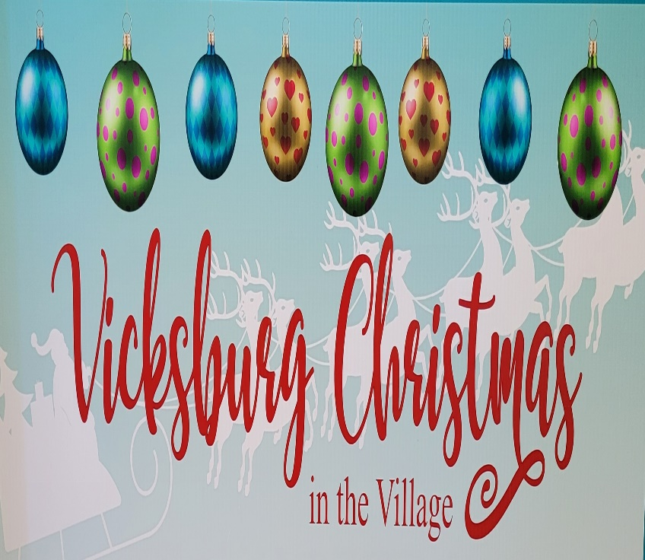

CASH PRIZES
Best Float: 1st place $300; 2nd place $200; 3rd Place $100
Best Fire Truck: $200; Best Other (bikes, boats, planes, trains?) Vehicle $200
Judging will be by a panel of celebrities

Rules
Floats should be a minimum of 8 feet in length not including the tow vehicle.
Tow vehicles must be decorated.
Floats should include skirt to cover wheels.
Floats must incorporate lights in the design. No candy thrown from floats or vehicles

Name of Float/Truck/Vehicle/Other____________________________________________
Sponsored By_____________________________________________________________
Contact_____________________________ Phone_______________________________
Email____________________________________________________________________
Float Description___________________________________________________________

Send the above information by Friday, November 25 to: Village of Vicksburg, 126 N. Kalamazoo Ave., Vicksburg, MI 49097
Questions to: info@vicksburgmi.org

