A Citizen’s Guide to BOAT & AUTO CAR

How we take care of our boats, personal watercrafts, mobile homes, cars and other vehicles greatly influences the health of the area lakes, rivers and streams. You can do your part to prevent pollution at the source by checking up on your marina and following a few simple tips.

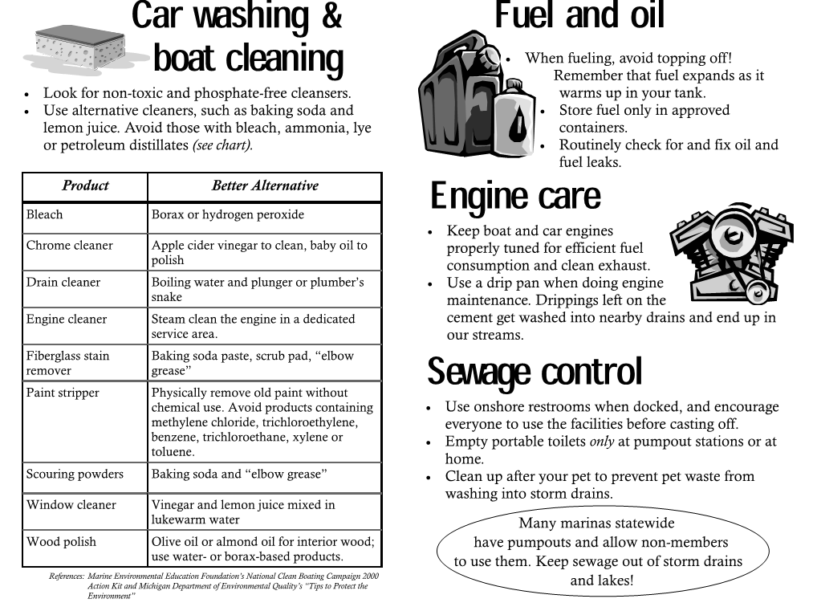

For more information, visit our website: www.vicksburgmi.org

