Joe Grimm & The Faygo Book
2019 Michigan Notable Book Award Winner
Vicksburg District Library
Wednesday, May 15th at 6:00pm

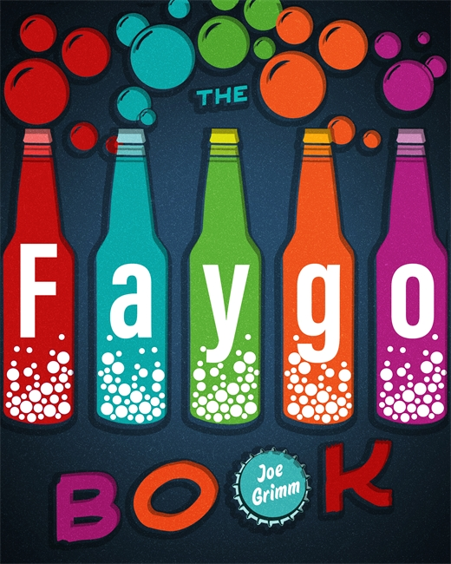

The Faygo Book is the social history of a company that has forged a bond with a city and its residents for more than a century. The story of Faygo, Detroit’s beloved soda pop, begins over a hundred years ago with two Russian immigrant brothers who were looking to get out of the baking business. Author Joe Grimm mixes the ingredients of a successful beverage company confected in dicey times in a boom-and-bust town. The Faygo Book is the story of a pop, a people, and a place. These stories and facts will tickle the taste buds and memories of Detroiters and Faygo lovers everywhere. There WILL be a pop quiz.

